PLANS AND ELEVATIONS
Pearson Edexcel - Tuesday 21 May 2019 - Paper 1 (Non-Calculator) Higher Tier
1.
Pearson Edexcel - Thursday 24 May 2018 - Paper 1 (Non-Calculator) Higher Tier
2.
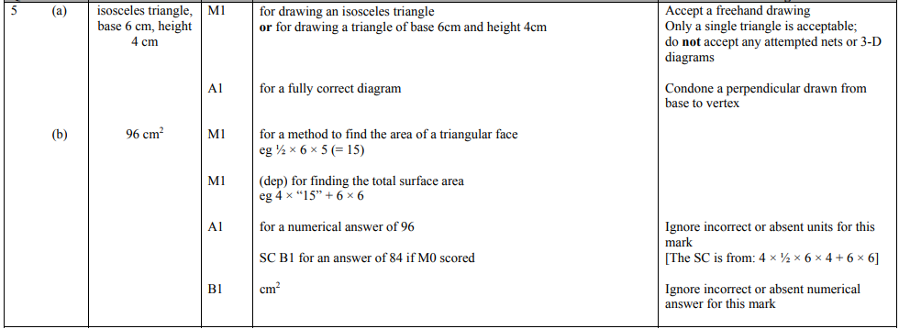
Pearson Edexcel - Thursday 8 June 2017 - Paper 2 (Calculator) Higher Tier
3.
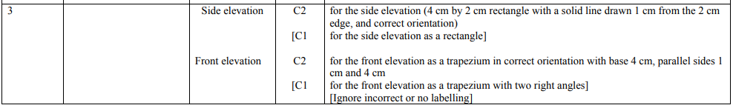
Pearson Edexcel - Specimen Papers Set 2 - Paper 3 (Calculator) Higher Tier
4.
Pearson Edexcel - Sample Paper 1 - (Non-Calculator) Higher Tier
5.
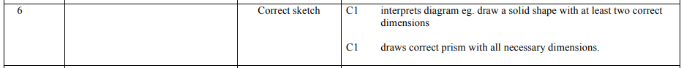
Pearson Edexcel - Monday 9 June 2014 - Paper 1 (Non-Calculator) Higher Tier
6.
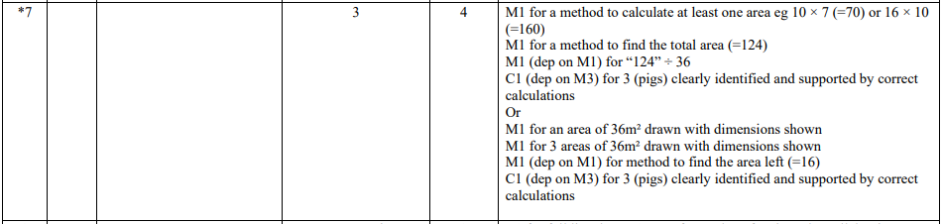
Pearson Edexcel - Friday 8 November 2013 - Paper 2 (Calculator) Higher Tier
7.
Pearson Edexcel - Friday 12 November 2010 - Paper 4 (Calculator) Higher Tier
8.
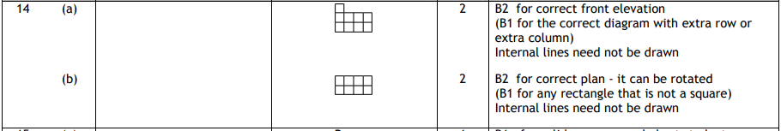
Pearson Edexcel - Friday 11 June 2010 - Paper 4 (Calculator) Higher Tier
9.
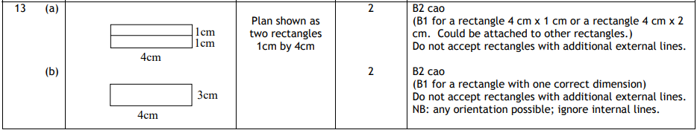
Pearson Edexcel - Tuesday 10 November 2009 - Paper 4 (Calculator) Higher Tier
10.
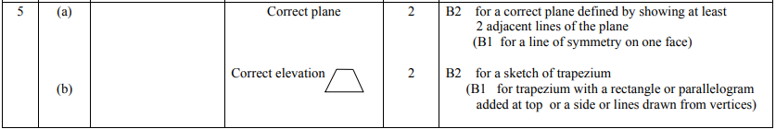
11.

